**E-commerce Application on IBM cloud foundry**

|  |  |
| --- | --- |
| **Date** | **26-10-2023** |
| **Team ID** | **4218** |
| **Project Name** | **E-Commerce Application on IBM Cloud Foundry** |

1. **Introduction**

The objectives involve creating an IBM Cloud Foundry-based artisanal e-commerce platform that connects skilled artisans with a worldwide audience. This platform will showcase handmade items, including exquisite jewelry and artistic home decor, with a focus on secure shopping, smooth payments, user-friendly checkout, and support for small artisan businesses to cultivate a thriving marketplace, this is achieved by using HTML,CSS for developing front-end for this platform

**2. Problem Statement**

Build an artisanal E-commerce platform using IBM Cloud Foundry. Showcase handmade products, from exquisite jewellery to artistic home decor. Implement secure shopping carts, smooth payment gateways, and an intuitive checkout process. Nurture creativity and support small businesses through an artisan's dream marketplace with high security and performance.

**Front-end Development**

**Step 1: Planning and Design**

-**Define Website Structure**: Begin by outlining the structure of your website. Identify the main pages, such as the home page, product listing, product details, cart, and checkout.

- **Responsive Design**: Ensure your design is responsive, meaning it adapts well to different screen sizes, such as desktops, tablets, and mobile devices. This involves designing for various viewports and considering how elements rearrange or resize.

**Step 2: HTML/CSS Development**

- **HTML Templates:** Create HTML templates for the different pages you outlined during the planning phase. Use semantic HTML elements to structure your pages effectively. Each page should have a consistent layout, including headers, footers, and navigation.

**- CSS Styling:** Write CSS styles to make your website visually appealing and in line with the design you planned. Use CSS to control fonts, colour, layout, and overall aesthetics. Consider using CSS frameworks like Bootstrap for faster development.

- **Responsive Design Implementation:** Ensure that your website design is fully responsive. Use media queries to adjust styles and layout based on the device's screen size. Test your website on various devices to make sure it looks good everywhere.

**Step 3: User Interface (UI)**

Design an attractive, user-friendly interface that enhances the shopping experience, focusing on layout, navigation, and visual appeal.

- **Navigation Menus**: Implement navigation menus to allow users to move between different sections of your website. Include a clear, consistent menu structure with links to key pages.

- **Product Listings**: Design and display your product listings in an organized and visually appealing manner. Use grids or lists to showcase products, and include essential details such as product names, prices, and images.

- **Product Details:** When a user clicks on a product, they should be taken to a product details page. Here, provides comprehensive information about the product, including descriptions, specifications, and images.

**Step 4: Interactive Elements**

- **Forms Validation**: Implement JavaScript to validate user input in forms, ensuring that they fill out required fields correctly. This prevents errors and improves the user experience.

- **Dynamic Cart Updates:** If a user adds products to their cart, use JavaScript to update the cart dynamically. This includes showing the current cart contents and the total price without requiring a page refresh.

- **Ratings and Reviews**: Users can interact with product ratings and reviews, read and leave feedback.

**Step 5: Creating a database**

**-Design**: Plan and structure your database with tables for products, users, orders, and categories, while establishing relationships between them.

**-Security**: Prioritize data security by implementing access controls, encryption, and regular backups to protect sensitive user and payment information.

**-Optimization**: Continuously monitor and optimize the database for performance, addressing slow queries and scaling as your e-commerce platform grows.

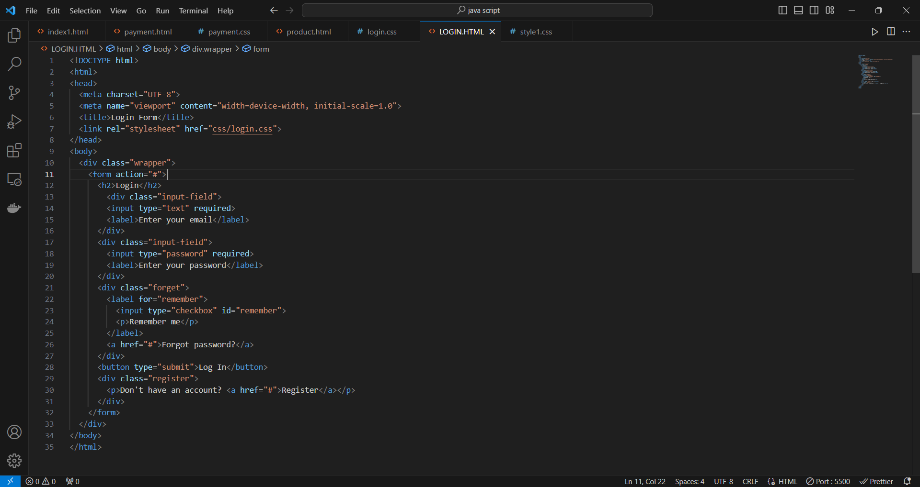

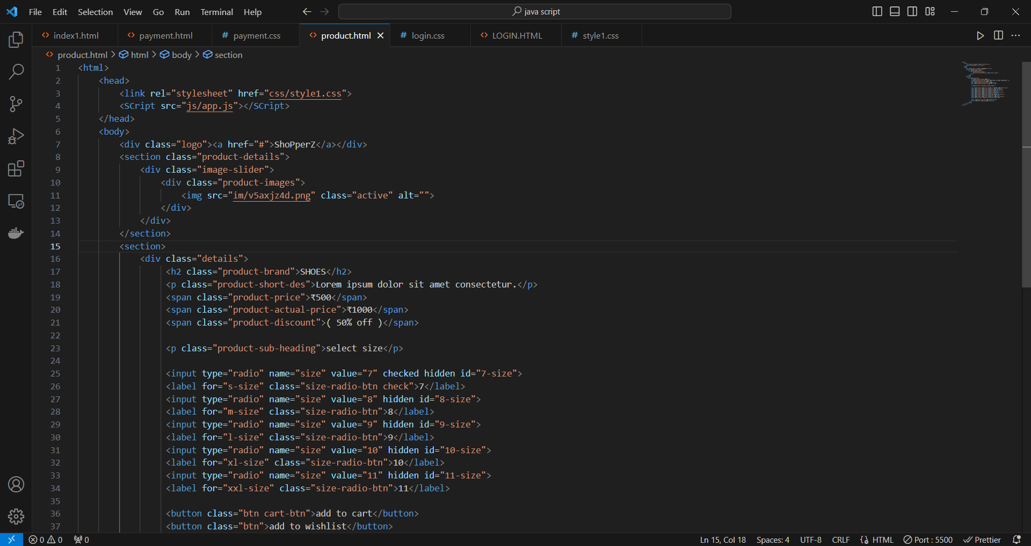

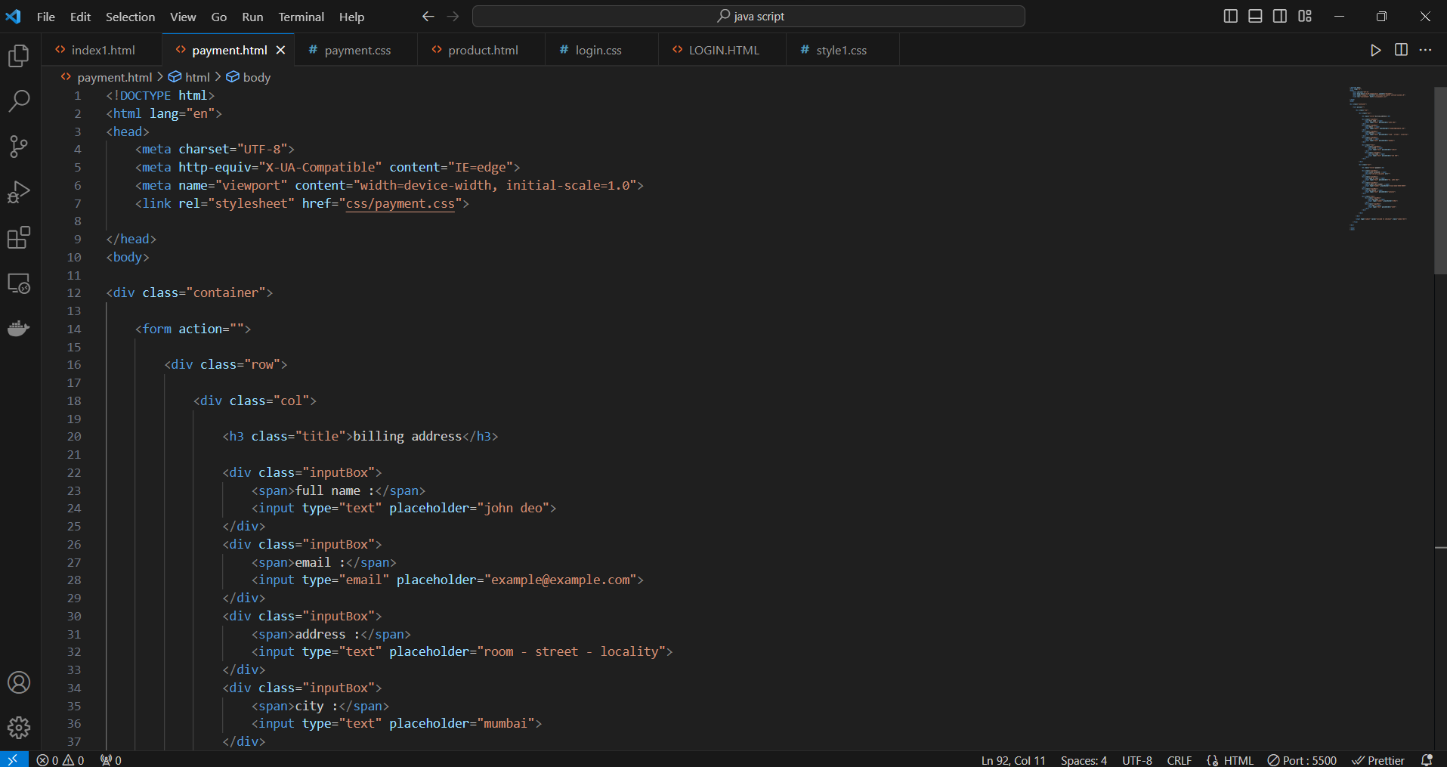

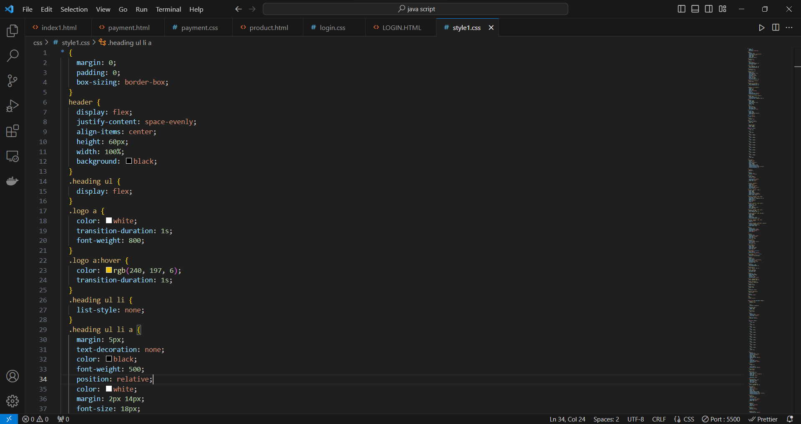

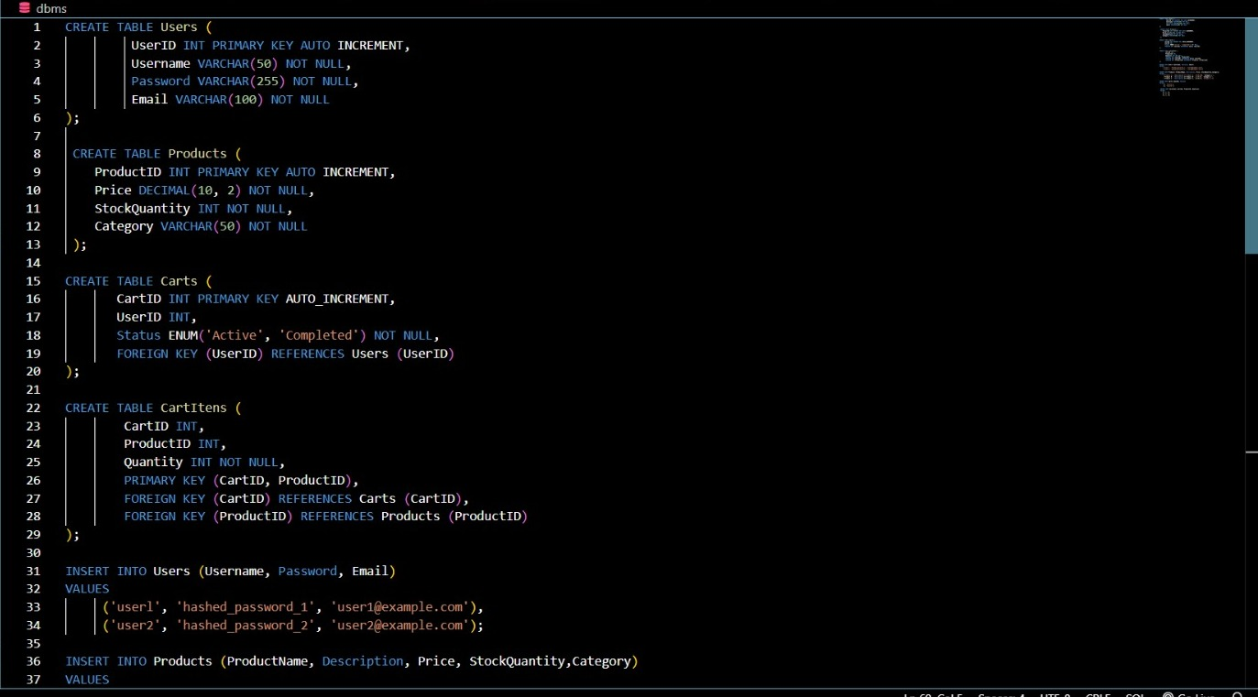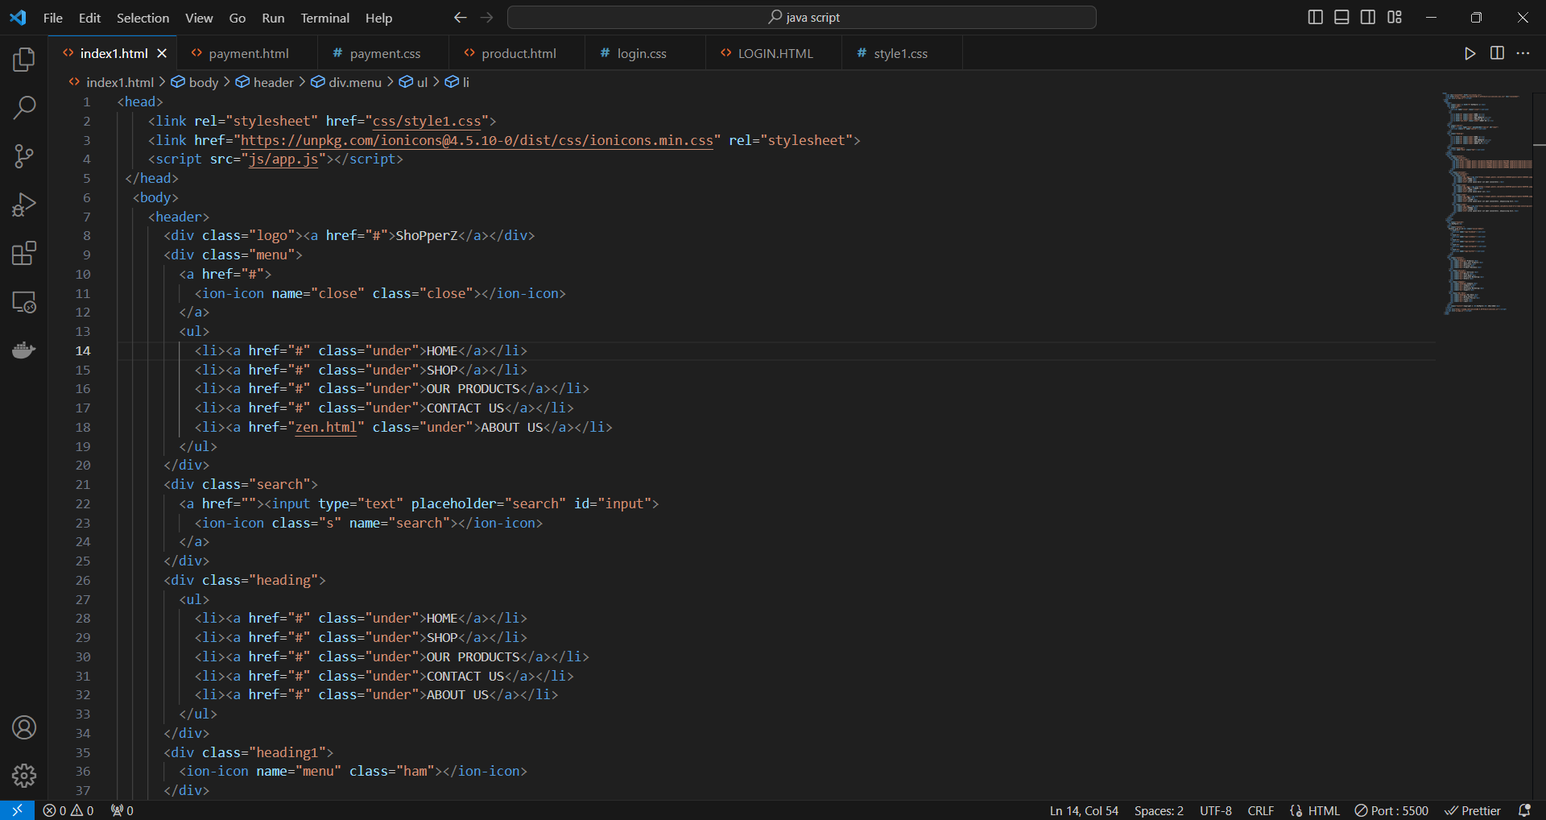

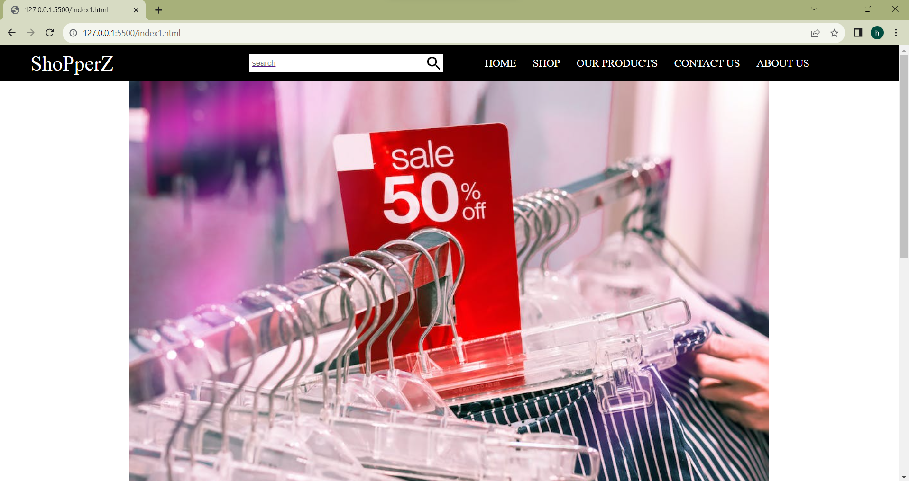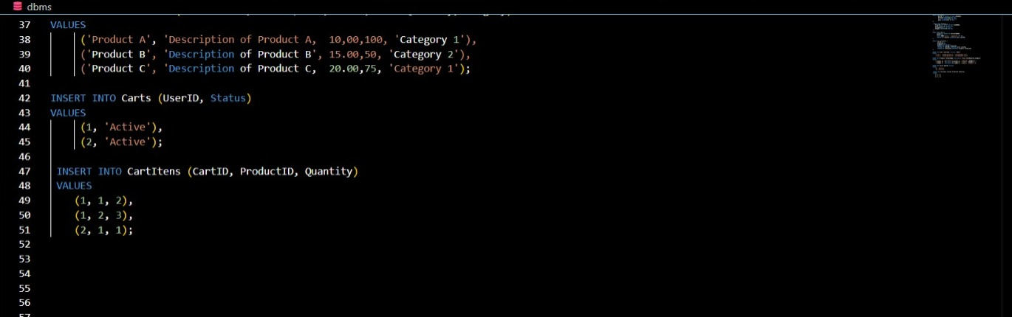

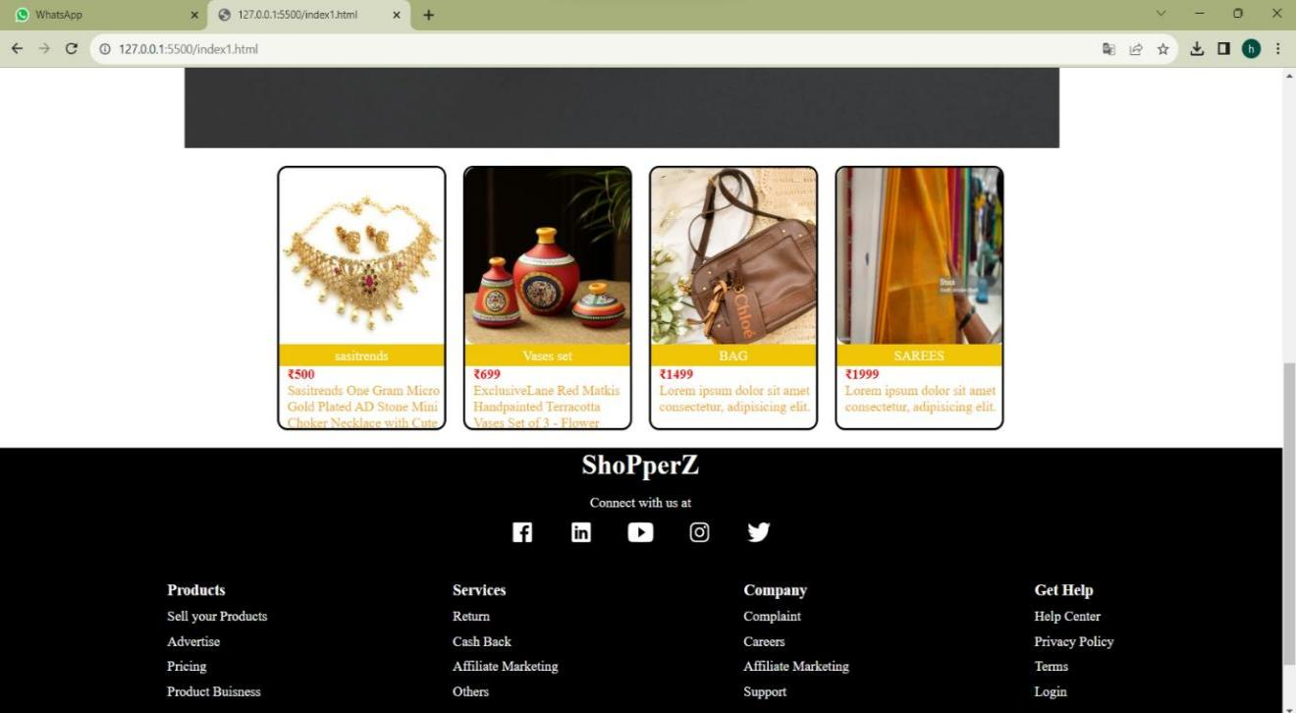

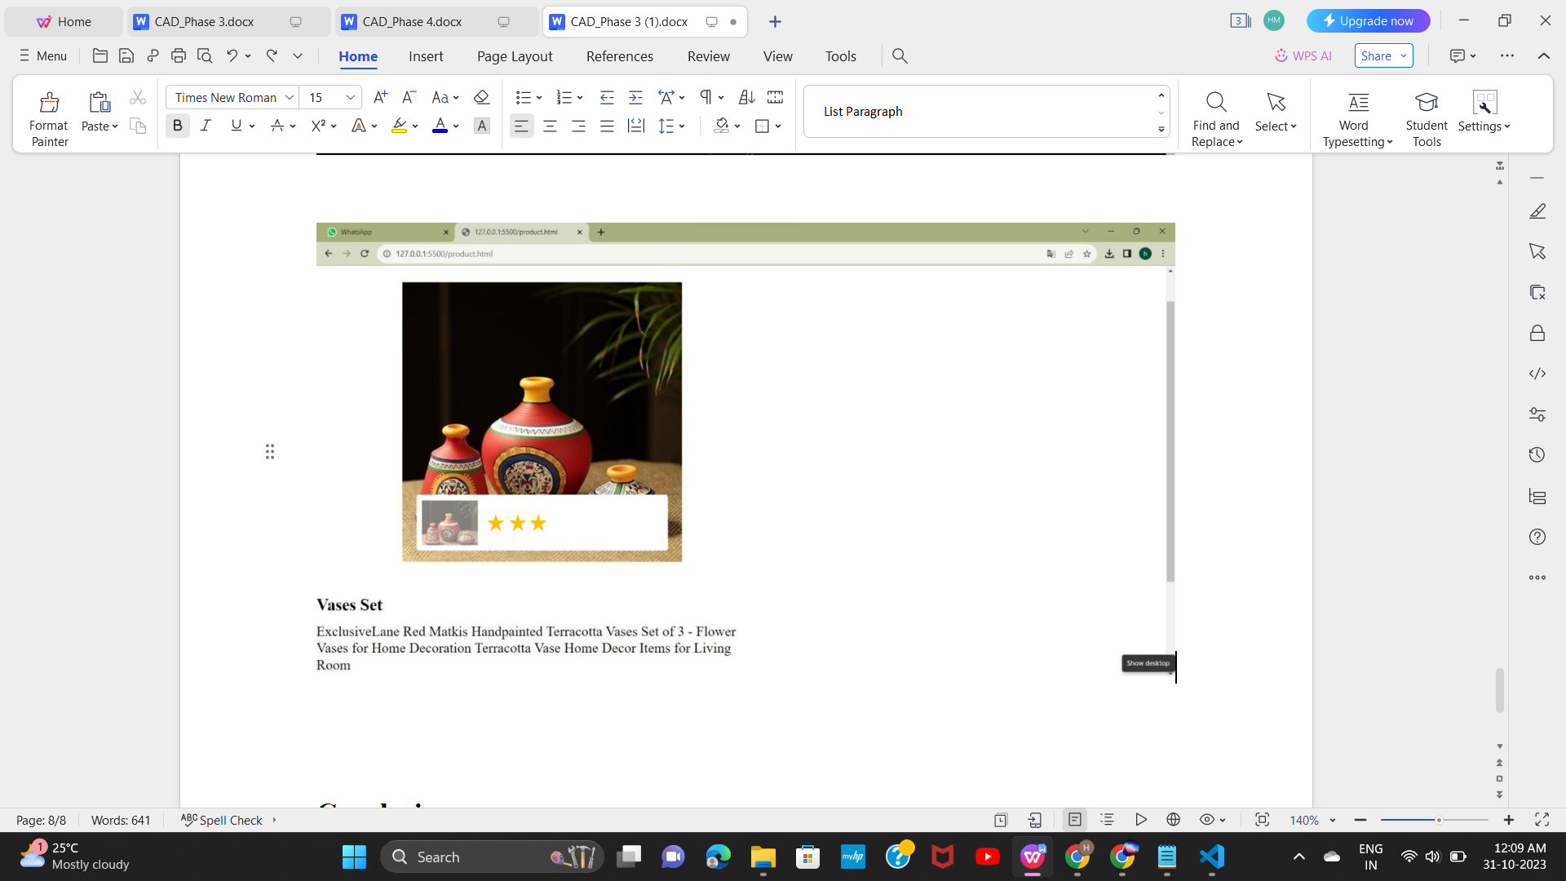

**Conclusion**

This project endeavors to create a vibrant artisanal e-commerce platform on IBM Cloud Foundry, fostering a community for skilled artisans and offering a secure, user-friendly shopping experience. By using html, css for front-end and database we have obtained a focus on creativity and small business support, it aspires to be a transformative marketplace for unique handmade products.